Title : Import the legacy data from different sources such as ( Excel , Sql Server, Oracle etc.) and load in the target system. ( You can download sample database such as Adventure works, Northwind, foodmart etc.).
Name : - Mehatab Mahibub Sanadi
Roll No. : - CO4050
Class : - BE Computer
Subject : - Business Intelligence
*********************************************************************
Step 1: Open Power BI
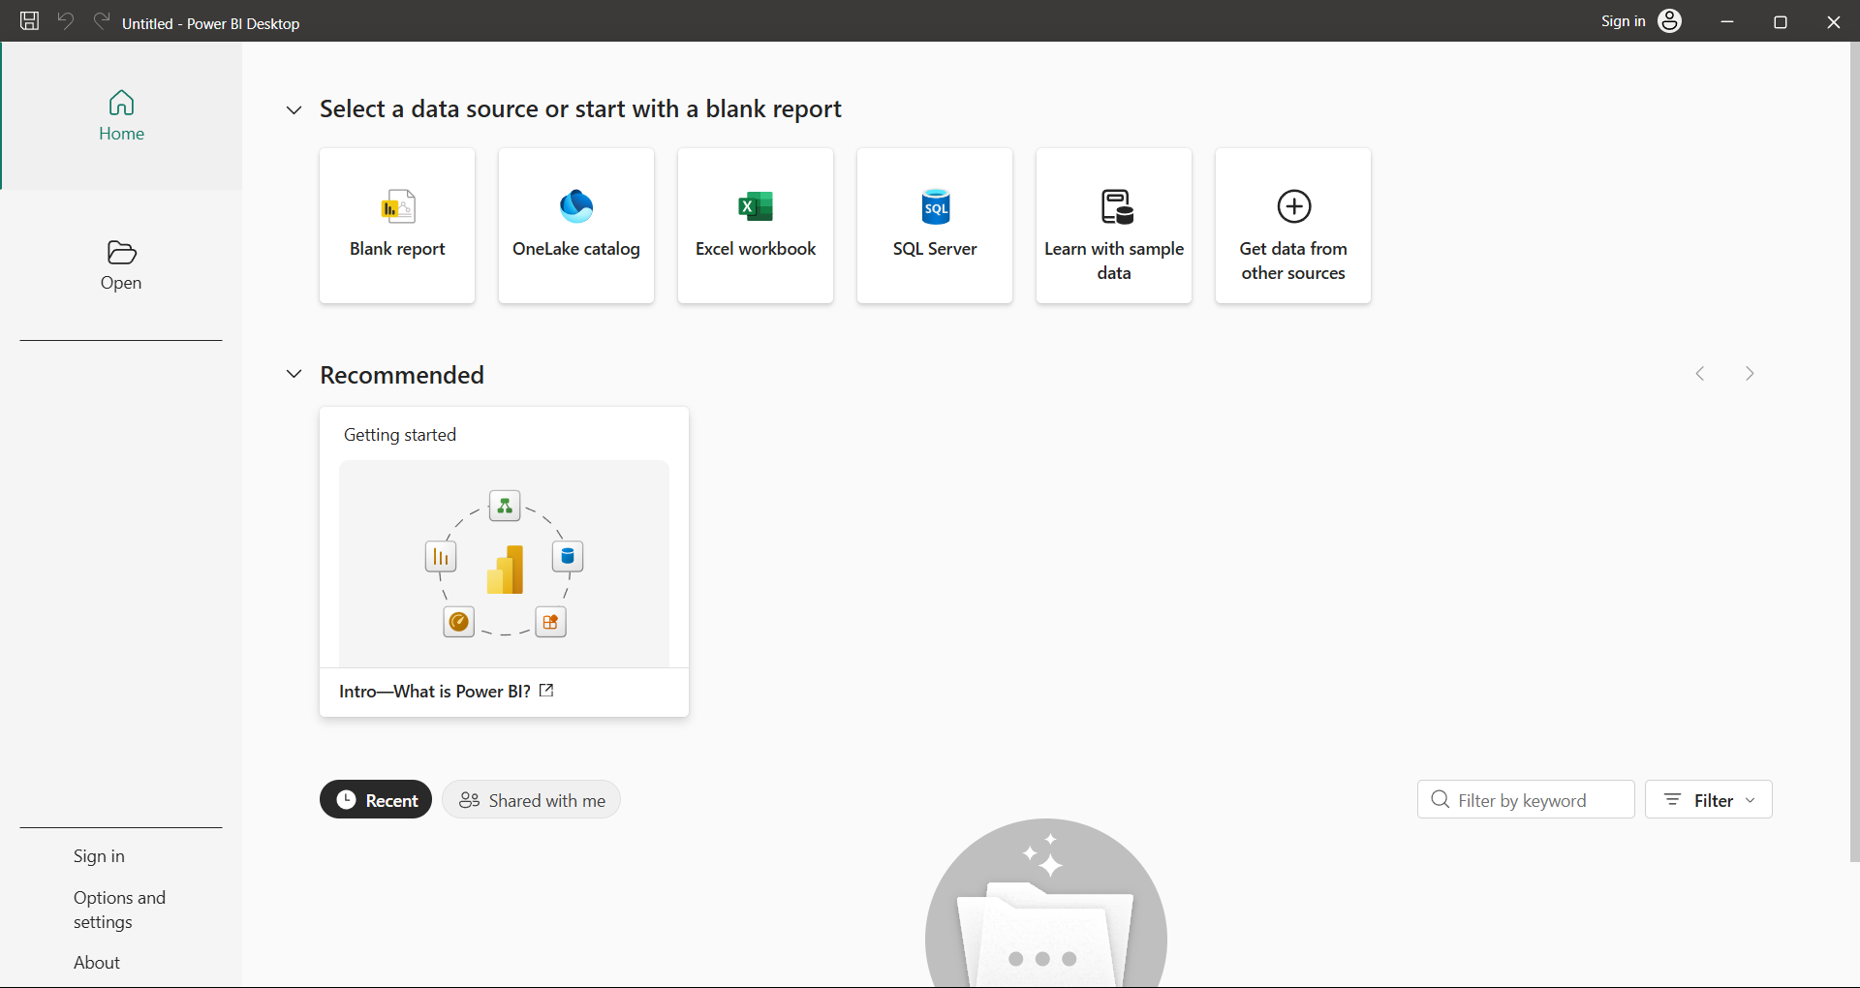
Step 2: Click on Get data following list will be displayed → select Excel
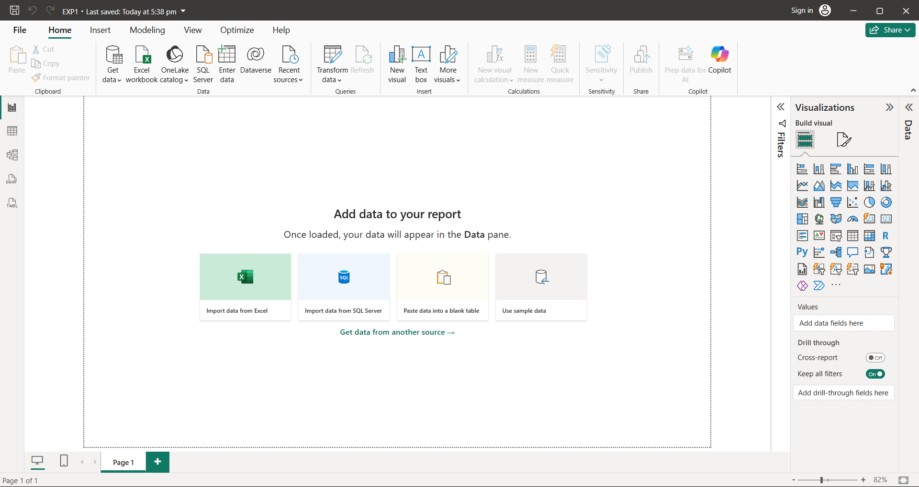
Step 3: Select required file and click on Open, Navigator screen appears
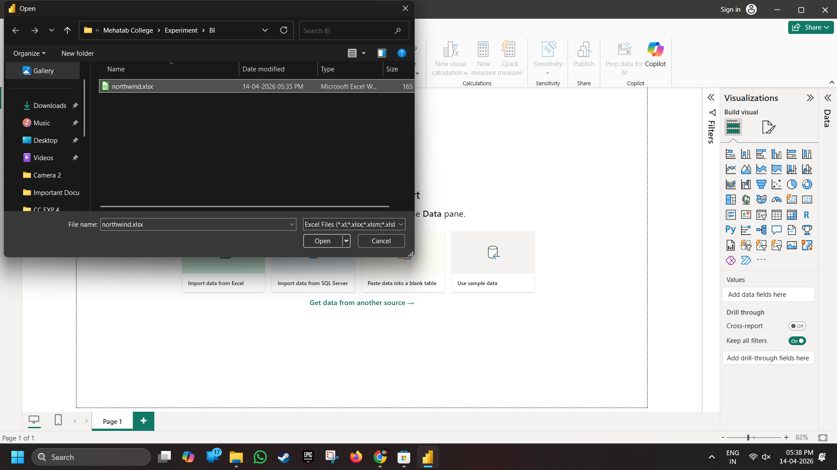
Step 4: Select file and click on edit
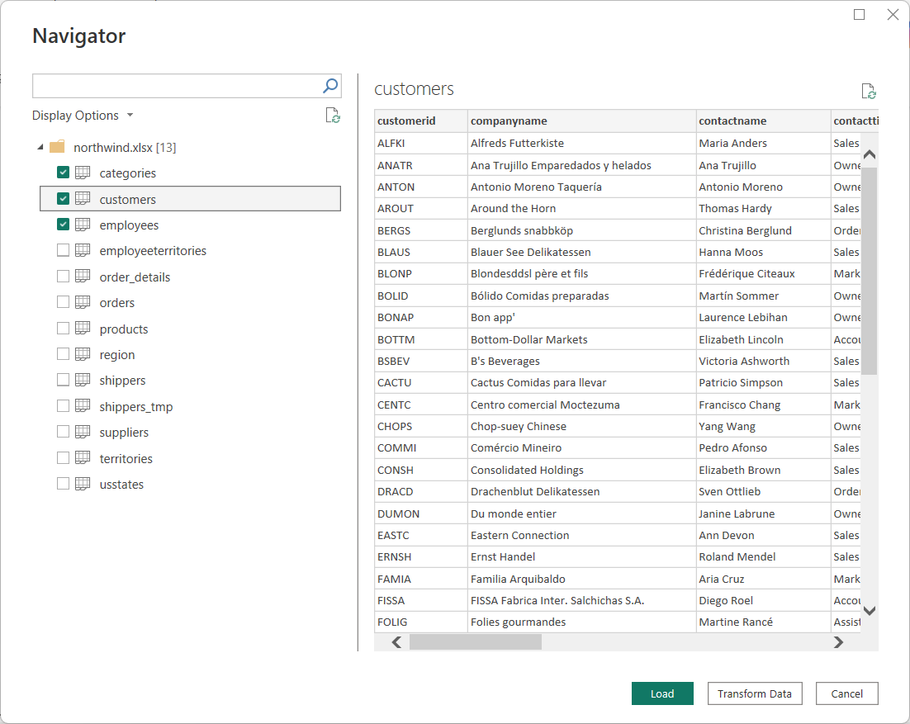
Step 5: Power query editor appears
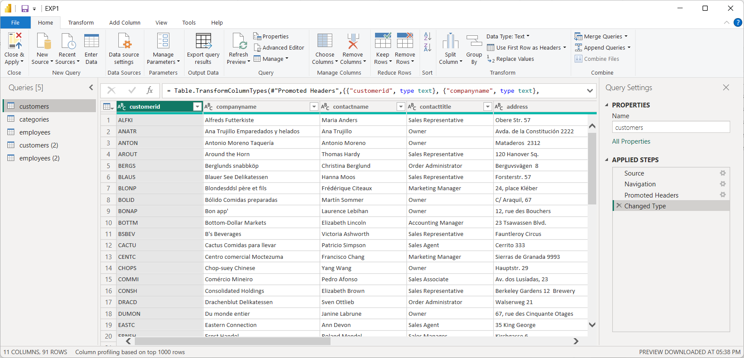
Step 6: Again, go to Get Data and select OData feed
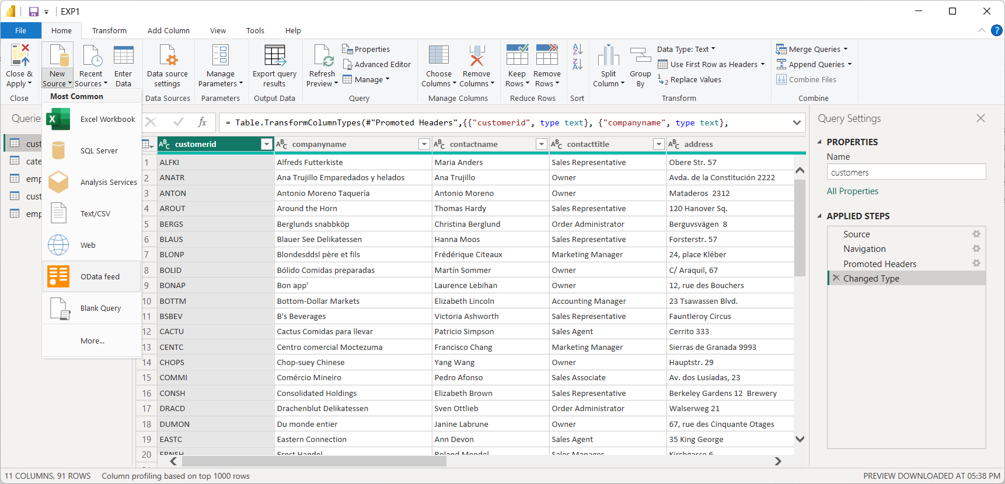
Step 7: Paste URL as http://services.odata.org/V3/Northwind/Northwind.svc/ Click on ok
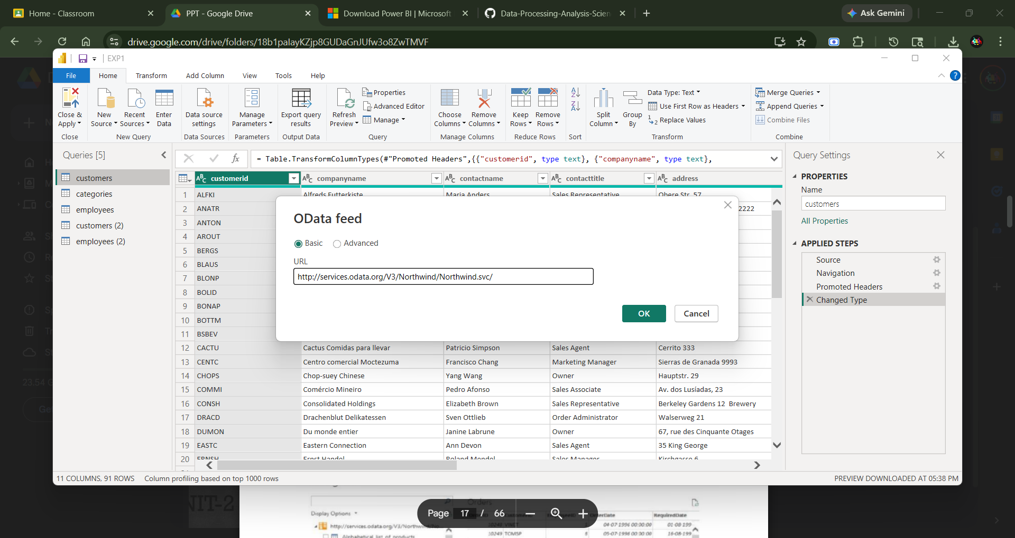
Step 8: Select orders table And click on edit
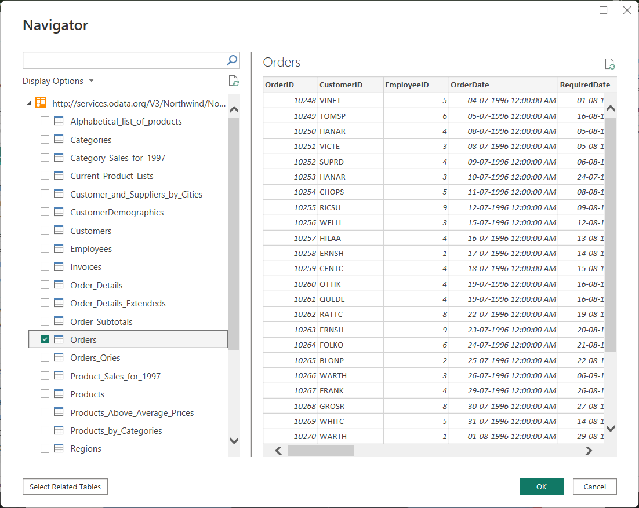
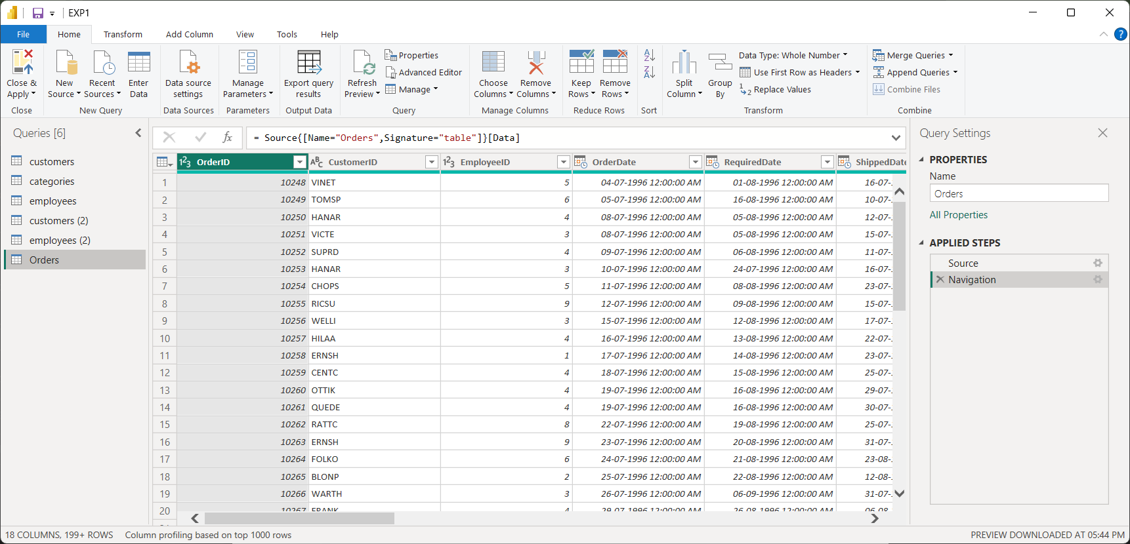
Conclusion: In this way we import the Legacy datasets using the Power BI Tool.

